

Welcome to python Course for Artificial Intelligence

This course consists of,

1. Python Basic
2. Python Intermediate
3. Python Advance

**Python Basic:**

**Variables**: Containers for storing data values.

* x = 5
* y = "Hello"

**Data Types:** Categories of data that tell the interpreter how the programmer intends to use the data.

int: Integer numbers

**Num =**

**Pi =**

**Name =**

**Status =**

* num = 10

float: Floating point numbers

* pi = 3.14

str: String (text)

* name = "Alice"

bool: Boolean (True or False)

* is_student = True

list: Ordered collection

* numbers = [1, 2, 3]

tuple: Ordered, immutable collection

* point = (10, 20)

dict: Unordered, key-value pairs

* person = {"name": "Bob", "age": 25}

**Program 1: Simple Calculator**

This program takes two numbers and performs basic arithmetic operations.

**v# Simple Calculator**

**num1 = 10**

**num2 = 5**

**addition = num1 + num2**

**subtraction = num1 - num2**

**multiplication = num1 * num2**

**division = num1 / num2**

**print(f"Addition: {addition}")**

**print(f"Subtraction: {subtraction}")**

**print(f"Multiplication: {multiplication}")**

**print(f"Division: {division}")**

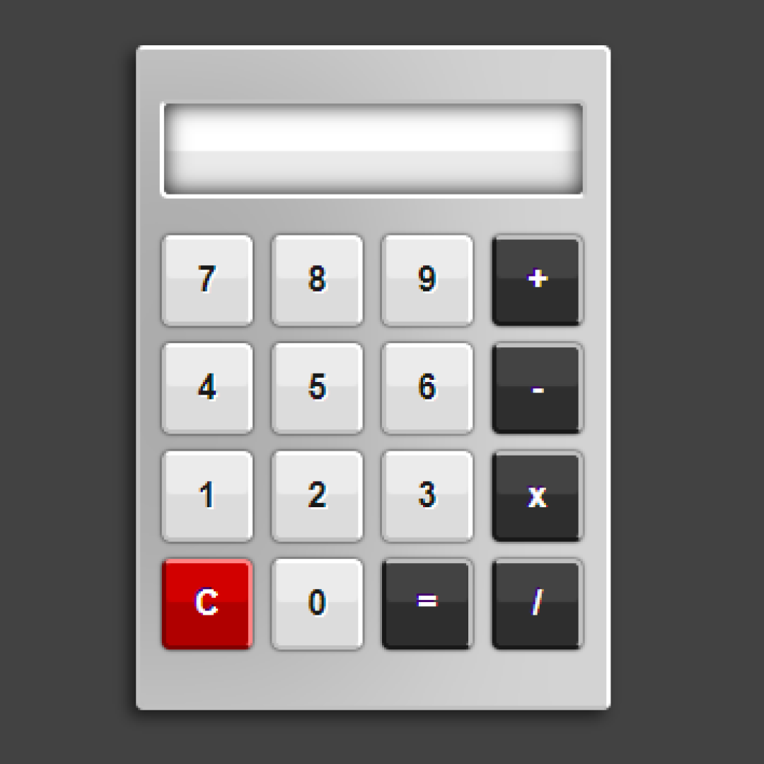

**Program 2: Greeting Message**

This program takes a user's name and prints a personalized greeting.

**# Greeting Message**

**name = "Alice"**

**greeting = f"Hello, {name}! Welcome to Python programming."**

**print(greeting)**

**Program 3: List Operations**

This program demonstrates basic list operations like appending, removing, and accessing elements.

**# List Operations**

**fruits = ["apple", "banana", "cherry"]**

**# Adding an element**

**fruits.append("orange")**

**# Removing an element**

**fruits.remove("banana")**

**# Accessing elements**

**first_fruit = fruits[0]**

**last_fruit = fruits[-1]**

**print(f"Fruits List: {fruits}")**

**print(f"First Fruit: {first_fruit}")**

**print(f"Last Fruit: {last_fruit}")**

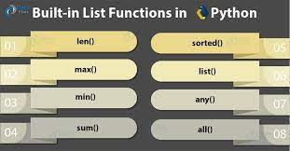

**Variables Rules:**

1 Must start with a letter or underscore (_): Variable names cannot start with a number.

* Valid: variable, _variable
* Invalid: 1variable

2 Can only contain alphanumeric characters and underscores: No spaces or special characters (except underscore).

* Valid: variable_1, var_name
* Invalid: variable-name, var name

3 Case-sensitive: Variable and variable are different variables.

* Example: Variable ≠ variable

4 Cannot be a reserved keyword: You cannot use Python keywords as variable names (e.g., if, else, while, etc.).

* Invalid: if, for, True

5 Should be descriptive: While not a strict rule, it's good practice to use meaningful names that describe the purpose of the variable.

* Example: count, total_sum